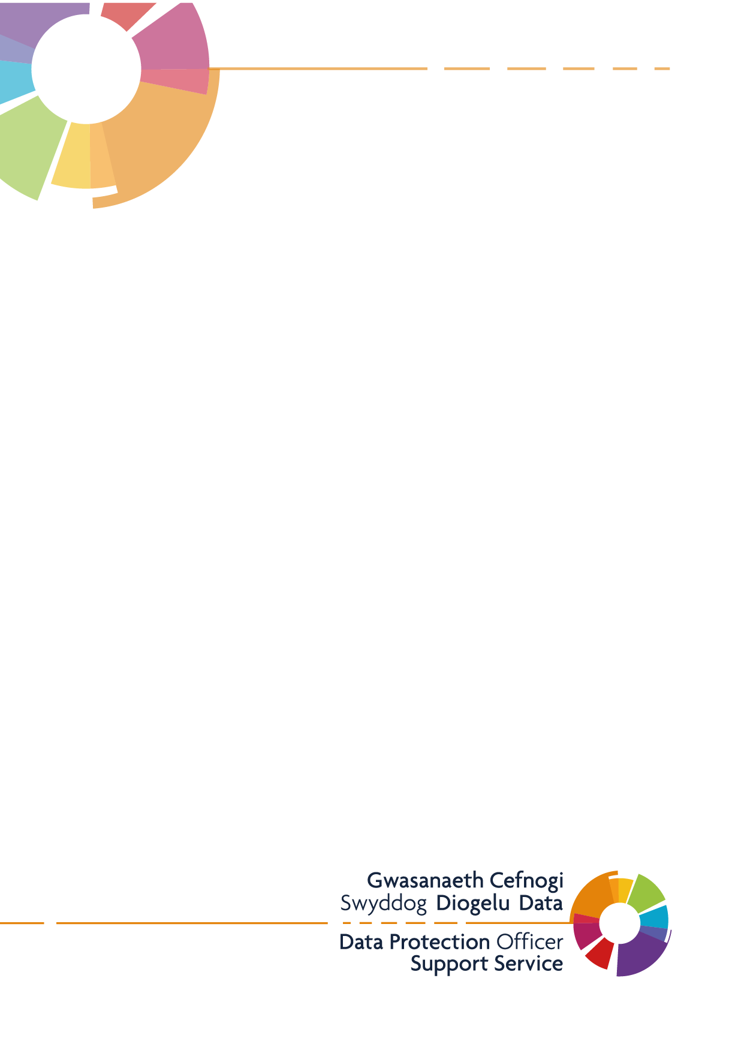
Bellevue Group Practice
Cookies – Privacy Information

Version: 1.1
Last Updated: 19/04/2021

What are Cookies?
Cookies are text files that are placed on to your device when you visit a website. They are widely used to make websites work efficiently and to collect standard information and track how you use websites for examples the pages you visit.
How we use Cookies
We use cookies to make our website work and to measure how you use our website for instance, we use language cookies to know what language you would like the web site displayed to you in, we also use YouTube cookies to embed videos in pages and Google Analytics cookies to track users’ behaviour whilst on the site, such as which pages you have visited. By understanding how people use our site, we can improve the navigation and content to better meet people’s needs. The data will not be used to identify any user personally. The cookies we use on our site are:

Cookie | Purpose | Expires
_hash | These cookies are set to allow us to identify the status of a user on our website and are generally used across the web for things such as log-in routines and shopping baskets. | 40 days
PHPSESSID | This cookie stores the identifier for your current session in PHP. | At end of session
CSRF token | Cross-Site Request Forgery (CSRF) is an attack that forces a user to perform unwanted actions on a website (for example your data could be hijacked and used to perform tasks). This cookie is required to protect users from a CSRF attack and allows us to mask your data. | At end of session
events-calendar | This is related to the events calendar on the website to save the users preference to whether they see a list or calendar view. The site detects what device they are using, sets the JSESSIONID as a cookie, and then sets an event calendar cookie. | 7 days
Cookieselection | This is related to the cookie information banner that appears on the site so when the user selects cookie preferences this prevents the banner from being shown again. | 7 days
Google Analytics:  _ga  _gid  _gat | These cookies above are used by Google Analytics to collect information about how visitors use our site. The cookies collect information in an anonymous form, including the number of visitors to the site, where visitors have come from geographically, and the pages they have visited, the devices and browsers the visitor is using. | 2 years  24 hours  end of session

How to manage cookies
You can set your browser not to accept cookies. You can also remove cookies from your web browser. Both these actions are completed through browser settings. To find out more about cookies and how to manage them, visit www.allaboutcookies.org
To opt out of being tracked by Google Analytics across all websites visit http://tools.google.com/dlpage/gaoptout.

